JOIN POOJA MISRA’S DISCOUNTED ONLINE SUMMER MAKEUP
CLASS……12 HOURS OF TRAINING ONLY FOR 5000 INR


 SO YOU WANT TO BE A MAKEUP- ARTIST?

I can’t blame you. It is a beautiful and inspiring career that is
rich with opportunity. Makeup is a multibillion dollar industry
and if you have passion for it, there is most definitely a
place for you in the field!
If going from where you are now to living your makeup
dream feels a million miles away…I can assure you, it is far
closer than you might realize. Read on for my road map to
achieving success in the amazing world of makeup.

EDUCATION
Having a
Hag a proper education is one of the most important educated. My advice would be to do all of them!
What
you know, the more success you may have
Formal makeup education can be achieved ONLINE in the comfort of your own space, you can learn at your own pace, practice as much as you would
Like…and master the craft…and go out there and make a name for yourself!

POOJA MISRA WILL TEACH YOU HOW!

FINDING A MENTOR…..

Being an apprentice to a professional makeup artist can be
invaluable. It provides you (the growing artist) with a nurturing
environment in which you will have the opportunity to learn the
skills of the master in a professional setting.
A mentorship with a professional artist can be a supercharged
education. Remember you’ll need to be well-trained before
approaching a mentor. Most will consider a solid education,
well-practiced skills and a great attitude to be incredible assets..

POOJA MISRA being a fabulous and patient mentor will help you excel!

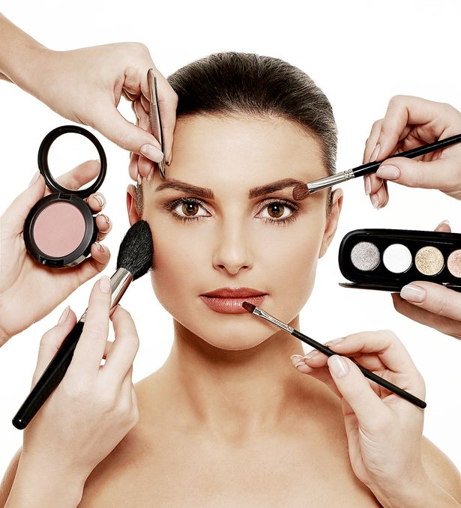

PRACTICE
Practice is the “X-Factor” for makeup artists.
And guess what? Unlike many other professions,
the magic ingredient is completely within your
control!
As silly as it may seem, this often overlooked step is one
of the main keys to major achievement and success in the
industry. If you want to be a makeup artist — an actual real
makeup artist who earns their living with brushes and colors
— practice is the single most important step you can take
toward achieving that goal.
If you are saying to yourself, “obviously, I already practice
for several hours a day”, then trust me when I tell you, you
are already leagues ahead of your competition. It is not your
makeup education that will get you a job in the industry, it il. Education is a necessity, but it
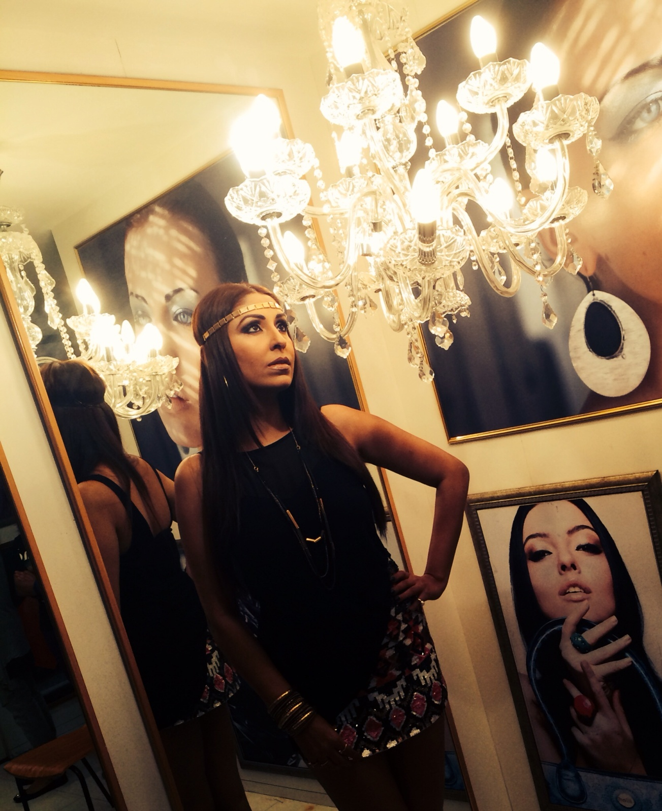
Talent, Skill, and Passion
People are drawn to a career in makeup for a variety of
reasons. Whatever yours may be, I am going to offer you a
bit of advice that may blow your mind: You do not need to
have any natural ability with makeup to have a tremendously
successful career.
Talent
Having a natural ability is always a great starting point. If you
find you can easily duplicate the looks you see in magazines
or your friends are always asking you to work on their faces,
you most likely have talent.
This is wonderful, but talent can also be a dangerous trap.
People with a natural talent sometimes think they do not
require practice or education, which means they are limited
to only their current level of ability.
Growth and expanded skills only come from increased
knowledge and practice (there’s that p-word again!). Talent
can be a tremendous blessing, if it is teamed with a lifelong
desire to learn and practice those skillsnot make you a skilled oPERF



Where you can practice and
gain experience

Makeup Counter
Almost everyone either wants their makeup done or wants
to learn some tips on how to do it better. If you want to gain
real hands-on experience, think about getting a job behind
the makeup counter.
No place has more diversity than a mall, and this will give
you the amazing opportunity (or advantage) of working on
people of all ages, skin types and ethnicities. Best of all, you
actually get paid to prefect your craft!
A lot of beginning artists aren’t sure where they can go to
practice their skills. Sure you can always practice on yourself,
friends and family, but you need regular practice on a variety
of faces – strangers’ faces! – if you want to truly enhance your
abilities. Here are a few suggestions on how to accomplish this


INTERNING FOR PRODUCTION HOUSES,FASHION AND THEATRE EVENTS ……

Volunteer your time to take up oppurtunuties to work for Production houses,at fashion and theatre events wherein you get a chance to work on actors,runway models and theatre cast so that you can develop your skill and get a chance to understand the difference in requirement of each so that you can catapult your confidence to the next level aswell as have something to be proud of and shine on your resume of work.



Hospitals, churches and old age homes

This is a beautiful way to gain practice and be a better
person. Hospitals, churches and old age homes are always
willing to set up programs for people who want to volunteer
their time and talents. Not only will you gain invaluable experience,
you’ll also get to brighten the days of those who
might not be in the best of health or who just want a little
company and kindness. This practice of volunteering will be
good for you and the person you are working on!

Everyone you know
Practice your skills on every single one of your friends and
family members
PORTFOLIO

Having a collection of your work available for potential clients
to see is critical to your advancement as an artist. Nothing will
get you work faster than a diverse and beautiful catalogue
that represents what you are capable of as an artist.
Would you hire someone to do your makeup if you could
see no example of their work? Of course not! And no one
else will either, so assembling the right portfolio is essential.
Your portfolio will need to consist of a variety of styles, but
each will differ slightly based on where you want to specialize.
• For a well-rounded portfolio, I would recommend having
several examples of straight makeup (a clean, simple
but flawless look), along with a few examples of editorial
makeup and avant garde, experimental, and/or fantasy
makeup.
• If you want to work in bridal, it would be best to have a
separate portfolio for that. Within, you can have varying
levels of makeup appropriate for those clients.
• If you want to work in film and TV, a reel will work well in
addition to your portfolio.
Portfolio Tips
Use Good Professional Photographs else do it ureself!
Using a good photographer is an investment as professionally shot pics can impress clients but if u r shot on cash u can also click the pics on yours mobile and broadcast on social media platforms

you work g Get a Variety of Models & Photos-
TEST&TRADE SHOOTS-
[CONCEPT SHOOTS]

Perfect opportunity to get amazing shots for your
portfolio. Everyone involved works at no charge in exchange
for great images.
Volunteer Work. Find work on student films, small television
and film production companies, fashion shows and local
theatres. The film and TV projects will be filmed giving
you work for your reel and the runway shows and theatre
productions always have a professional photographer.rofessional

Types of Portfolios

Print Portfolio
This is the standard leather
binder that contains plastic
sleeves with actual images
and tear sheets. They can be
costly and are sometimes
required by agencies and
specific projects.
Online Portfolio
This is becoming the preferred
portfolio. It can be kept on your
website, your social media
feeds and even in a tablet so
you can carry it to meetings
with potential clients.



MARKETING……..[MOST IMPORTANT PART]

If you do not properly market yourself, how is anyone going
to find you? It is essential that you get yourself out there, if
you plan to have a far-reaching career.
The internet is nearly all you need! Yes, you may want to get
business cards, but how often do people really hand them to
one another anymore… so get business cards printed when
you can, but get yourself online now!

FOCUS ON……

A Website
This is the easiest way to have your work available to the
world 24 hours a day, seven days a week. A simple, clear
page with contact information and another with access to
your ever-expanding portfolio is an essential marketing tool.

A Blog
If you are blessed with the gift of writing and want to be heard,
you should start a blog! This is an amazing opportunity for you
to get your knowledge and expertise out there on a broader
level. Whether you share product tips and knowledge, talk
about your favorite trends, teach application, or all of the
above, a blog can be a great way to get people to know your
name.

Social Media
Possibly the most powerful of all marketing tools, Facebook,
YouTube, Instagram and every other platform have created
celebrities across the globe! This could be an amazing
opportunity for you. Even if your goal is not to monetize your
social media efforts, the far reach of these sites could gain
you worldwide fans and clients.
You can make a big impact if you establish yourself as a daily

Business Cards
It is the oldest marketing tool in the book and still a useful
one! Have one or two in your pocket at all times. My tip with these is keep it simple!

Marketing Education
Don’t be afraid to take some small business marketing or advertising
seminars (even free ones online). This will give you
invaluable insights into gaining customers, creating a brand
and extending your reach.
When you get yourself online and begin proper marketing,
you establish yourself as a brand. That is a powerful step
necessary for a successful future. If you want to make an impact
and broaden your career, it is essential that you take
some, if not all, of the above steps.

Find more information on the Beauty Buzz Blog:
How to Build a Website
How to Write a Blog
Social Media for Businesses
Additional Business Resources

CUSTOMER SERVICE

Makeup is a career that is entirely about the satisfaction
of the customer. Your education will teach you how to
properly behave with a client, but only practice can make it
second nature.
• Listen: Your client has come to you for a service and
chances are they want something specific, whether it be
a specific look, an event, or lessons. Your job is to hear
and deliver.
• Check the attitude: If someone does not like what you
do, correct it with a smile. As amazing as the look you
created may be, the client has to wear it, so make them
happy at all costs. Makeup is all about the feel-good
factor and your client should feel good (no, GREAT!)
when you are done, even if it requires a few small (or
large) adjustments. It only take a few minutes to adjust it
to their liking and you will most likely gain a referral.
• Stay positive: Your excitement and passion is contagious
to the client you work on. If you love what you do and
share your service with a positive attitude, you are very
likely to turn a one-time customer into a life-long client.
• Go the extra mile: When I am applying makeup, I always
try to teach my secrets to my clients. Each and every
time, I try to improve on their makeup knowledge a little.
You might think this would leave me with no clients at all,
but instead it has built me a dedicated roster. Share what
you know.

Want to get a master class in customer service and learn a
TON about applying makeup on every possible face?
Get a job at a makeup counter. You will have the opportunity
to work with hundreds of people every week. You can practice
listening and kindness while getting a ton of practical work
on a multitude of different faces. This is the most amazing
opportunity to get paid to learn!
Also, if you can learn to be calm under pressure in this
“client comes first” environment, then you will be cool as a
cucumber on film sets, with celebrity clients, major editorials
or any other high profile job.
THE TAKEAWAYS
Many believe that a successful career in the highly
competitive field of Makeup depends entirely upon luck. I
agree…BUT I also believe we make our own luck!
If you want to step into this amazing world of artistry, you
would be smart to follow the roadmap I laid out above.
Take a positive step toward achieving your dreams this very
moment by watching a video, reading about a technique
and signing up for the training program that is right for you. If
makeup is your passion, then following that map will prepare
you for success, and a person prepared for success is usually
the one “lucky” enough to find it.
What career is better than one that gifts its clients with selfconfidence?
Isn’t it time you join us in this beautiful and noble
profession?
NATHAN



ABOUT QC MAKEUP ACADEMY

COURSE SYLLABUS

SESSION 1- HOW TO KEEP YOUR SKIN AND HAIR BEAUTIFUL FROM INSIDE BY NUTRITION,FACEPACK ETC...SO THAT ON APPLYING MAKEUP YOU GO TO THE NEXT LEVEL OF BEAUTY

SESSION 2-THE VARIOUS TYPES OF FACE CUTS,EYES,NOSE,MOUTH AND THE KIND OF BROWS AND MAKE UP TRICKS THAT SUIT EACH ASWELL THE ART OF
APPLYING THE RIGHT FOUNDATION/BASE

SESSION 3-THE VARIOUS TYPES OF MAKE UP FROM DAY WEAR TO NIGHT WEAR TO VARIOUS TRENDING MAKEUP FOR TV,PRINT AND MOVIE SHOOTS....

SESSION 4- WE WILL BE HELPING YOU ADVERTISE YOURSELF AS A MAKE UP ARTIST ON VARIOUS FREE APPS AND FORUMS ONLINE USING KEYWORDS THAT WILL HELP YOU RECOVER YOUR COURSE FEE....

SESSION 5- WE WILL BE TAKING YOU SHOPPING FOR MAKEUP AND HELP YOU PUT TOGETHER A MAKE UP KIT SO THAT AS SOON AS YOU FINISH THIS COURSE YOU WILL BE READY TO JUMP INTO THE MARKET AS A PROFFESSIONAL MAKE UP ARTIST....

ONLINE COURSE ON 5TH AND 6TH MAY ONLY RS 5000
LIMITED SEATS……GOING! GOING! GONE!
BOOK YOUR SEAT NOW……
EMAIL- confidential.pooja@gmail.com
FACEBOOK- @Pooja Misra Production
TWITTER-@sparemesayspm
INSTAGARAM- Pooja Misra Production
WEBSITE- www.poojamisra.com
12 hours of training worth 5 lacks only at 5000 rupees!
Grab it before its gone!

SESSION 1- HOW TO KEEP YOUR SKIN AND HAIR BEAUTIFUL FROM INSIDE BY NUTRITION,FACEPACK ETC...SO THAT ON APPLYING MAKEUP YOU GO TO THE NEXT LEVEL OF BEAUTY

SESSION 2-THE VARIOUS TYPES OF FACE CUTS,EYES,NOSE,MOUTH AND THE KIND OF BROWS AND MAKE UP TRICKS THAT SUIT EACH ASWELL THE ART OF
APPLYING THE RIGHT FOUNDATION/BASE

SESSION 3-THE VARIOUS TYPES OF MAKE UP FROM DAY WEAR TO NIGHT WEAR TO VARIOUS TRENDING MAKEUP FOR TV,PRINT AND MOVIE SHOOTS....

SESSION 4- WE WILL BE HELPING YOU ADVERTISE YOURSELF AS A MAKE UP ARTIST ON VARIOUS FREE APPS AND FORUMS ONLINE USING KEYWORDS THAT WILL HELP YOU RECOVER YOUR COURSE FEE....

SESSION 5- WE WILL BE TAKING YOU SHOPPING FOR MAKEUP AND HELP YOU PUT TOGETHER A MAKE UP KIT SO THAT AS SOON AS YOU FINISH THIS COURSE YOU WILL BE READY TO JUMP INTO THE MARKET AS A PROFFESSIONAL MAKE UP ARTIST....

SESSION 1- HOW TO KEEP YOUR SKIN AND HAIR BEAUTIFUL FROM INSIDE BY NUTRITION,FACEPACK ETC...SO THAT ON APPLYING MAKEUP YOU GO TO THE NEXT LEVEL OF BEAUTY

WE ARE GLAD TO INFORM YOU ABOUT OUR MAKE UP WORK SHOP ON SAT&SUN 11TH&12TH MARCH 2017 IN PUNE.....
THE CLASS WILL BE IN PUNE GIVEN BY NONE OTHER THAN CELEBRITY POOJA MISRA [www.poojamisra.com]

U can also check out the video on youtube channel –POOJA MISRRA ORIGINAL
SESSION 1- HOW TO KEEP YOUR SKIN AND HAIR BEAUTIFUL FROM INSIDE BY NUTRITION,FACEPACK ETC...SO THAT ON APPLYING MAKEUP YOU GO TO THE NEXT LEVEL OF BEAUTY

SESSION 2-THE VARIOUS TYPES OF FACE CUTS,EYES,NOSE,MOUTH AND THE KIND OF BROWS AND MAKE UP TRICKS THAT SUIT EACH ASWELL THE ART OF
APPLYING THE RIGHT FOUNDATION/BASE

SESSION 3-THE VARIOUS TYPES OF MAKE UP FROM DAY WEAR TO NIGHT WEAR TO VARIOUS TRENDING MAKEUP FOR TV,PRINT AND MOVIE SHOOTS....

SESSION 4- WE WILL BE HELPING YOU ADVERTISE YOURSELF AS A MAKE UP ARTIST ON VARIOUS FREE APPS AND FORUMS ONLINE USING KEYWORDS THAT WILL HELP YOU RECOVER YOUR COURSE FEE....

SESSION 5- WE WILL BE TAKING YOU SHOPPING FOR MAKEUP AND HELP YOU PUT TOGETHER A MAKE UP KIT SO THAT AS SOON AS YOU FINISH THIS COURSE YOU WILL BE READY TO JUMP INTO THE MARKET AS A PROFFESSIONAL MAKE UP ARTIST....

SO KINDLY MAIL BACK ON justice4poojamisrra@gmail.com or give us a call on 8408035327 and confirm your seat at the makeup workshop on11th and 12th march sat-sun, @bunglow no.T1b,florida estate,keshav nagar,mundwa,pune 36, LANDMARK- Opp Navgrah mandir
SO SPREAD THE WORD AROUND AMONGST YOUR FAMILY AND FRIENDS AND MAIL US ON justice4poojamisrra@gmail.com AND LET US KNOW IF YOU WOULD LIKE TO JOIN IN!
WITH YOU IN YOUR SUCCESS,
POOJA MISRA

